The Risen King: Death Defeated, Hope Restored
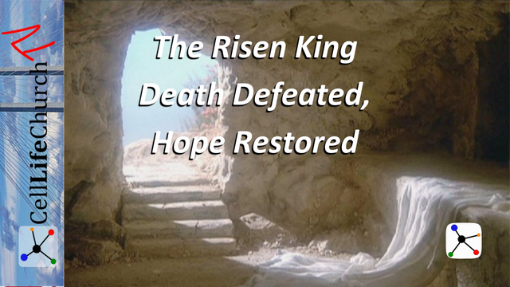
The tomb is empty, hope is alive! This Easter, discover how the resurrection changes everything for you today and forever.

Introduction
Last week, we celebrated Palm Sunday and the beginning of Passion Week; the journey of Jesus to the cross. We reflected on how the crowds praised Him, but how quickly the cries of "Hosanna" turned into "Crucify Him."
Today, we come to the resurrection, the very foundation of our faith. Easter is not just a holiday, it is the ultimate declaration that death is defeated and hope is alive.
The resurrection is more than a historical event. It is a life-changing reality that transforms everything. Jesus did not just rise from the dead for Himself. He rose for us to bring new life, eternal hope, and victory over sin.

The Empty Tomb Confirms the Power of God
We read what the angels told the disciples when they found the empty tomb in the first part of Matthew 28:6, which says:

Matthew 28:6
(6) He is not here; he has risen, just as he said.
The resurrection of Jesus is not simply a symbol of hope. It is the demonstration of God’s unrivaled power over death. When Jesus rose from the grave, He defeated the final enemy that no one else could conquer.
The tomb, once sealed by Rome’s authority, became a divine proclamation: God keeps His word. Jesus said He would rise again, and He did. The same power that raised Christ from the dead now works in us who believe.
This truth has profound implications:
- No sin is too great that it cannot be forgiven.
- No failure is final when God is involved.
- No darkness can overcome the light of Christ.
The empty tomb is a declaration that hope always has the final word when Jesus is involved.
Reflect on your life. What area of your life feels hopeless right now? How does the power of the resurrection speak into that place?

The Risen Jesus Offers Peace, Not Condemnation
We read about one of the first times Jesus appeared to the disciples after his resurrection in John 20:19-21, which says:

John 20:19-21
(19) On the evening of that first day of the week, when the disciples were together, with the doors locked for fear of the Jewish leaders, Jesus came and stood among them and said, "Peace be with you!" (20) After he said this, he showed them his hands and side. The disciples were overjoyed when they saw the Lord. (21) Again Jesus said, "Peace be with you! As the Father has sent me, I am sending you."
After the resurrection, Jesus could have rebuked the disciples for abandoning Him. But instead, He came into the room where they hid in fear and offered peace. This is the heart of grace.
Even in our failures, fears, and doubts, the risen Christ meets us not with judgment, but with restoration. His scars didn’t vanish. They remained visible to show that His love had endured suffering for our sake.
This peace is not circumstantial. It’s not based on what we’ve done, but on who Jesus is. Romans 5:1 tells us:

Romans 5:1
(1) Therefore, since we have been justified through faith, we have peace with God through our Lord Jesus Christ,
Jesus' resurrection brings:
- Peace with God – our sin no longer separates us.
- Peace within ourselves – our shame is covered by His grace.
- Peace for our future – we know death is not the end.
He didn't come to condemn the broken. He came to restore them.
Think about your life. What guilt or fear are you holding onto that Jesus has already paid for? Are you living in the peace He offers?

The Resurrection Calls Us to Live as Witnesses of Hope
We read Jesus’ encouragement and instructions for the disciples in Luke 24:26-28, which says:

Luke 24:46-48
(46) He told them, "This is what is written: The Messiah will suffer and rise from the dead on the third day, (47) and repentance for the forgiveness of sins will be preached in his name to all nations, beginning at Jerusalem. (48) You are witnesses of these things.
The resurrection was not just meant to be experienced, it was meant to be proclaimed. Jesus didn’t just appear to the disciples to comfort them; He commissioned them.
As those who have encountered the risen Christ, we are not just believers, we are witnesses. We testify, by our words and actions, to a living Savior. The resurrection is not just a message for Easter Sunday. It is the foundation of the Gospel and the heart of our mission.
We are called to:
- Live with boldness – fear no longer controls us.
- Serve with love – we model the sacrificial love of Jesus.
- Speak with truth – the world needs to hear that hope is alive.
This is the power of resurrection living: being part of God’s ongoing story of redemption in the world.
Reflect back on your life. Who in your life needs to hear about the hope of Jesus? How can your life reflect His resurrection power?

Conclusion
Easter is the great reversal. Where there was death, there is now life. Where there was despair, there is now hope. Where there was fear, there is now peace.
Jesus' resurrection changes everything; not just for eternity, but for today.
If Jesus is alive, then hope is alive.
If Jesus is risen, then we have a purpose.
If Jesus conquered the grave, then we can face anything with faith.
This Easter, receive the peace of Jesus, rejoice in the power of His resurrection, and respond by living as a witness of His hope.
If you are ready to say yes to Jesus, accept His free gift of salvation, and live a life of purpose and peace then you simply need to surrender to Jesus. Scripture tells us all we need to do to receive Christ is to believe in our heart and confess with our mouth that Jesus is Lord.
If you have asked Jesus to forgive you and be your Lord, we would love to know. You can message us or click the “I said Yes to Jesus” link at the top of our website. We would love to help you as you embark on this journey.

