The Triumphal Entry: Welcoming the King

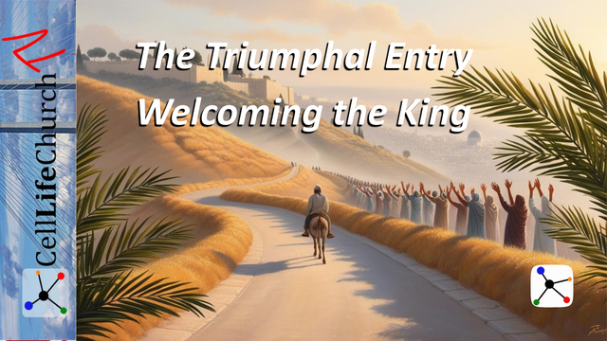Palm Sunday begins Passion Week. Join us as we explore the meaning behind Jesus’ Triumphal Entry and how to truly welcome Him as King.

## Introduction

Palm Sunday marks the beginning of Passion Week. This is the most significant week in the Christian faith. It is a week of both triumph and tragedy, celebration and sacrifice. Jesus’ arrival in Jerusalem wasn’t random, it was intentional and prophetic. He entered the city as a King, but not in the way the world expected.

As people spread their cloaks in the street and waved palm branches, shouting “Hosanna,” they were welcoming a Messiah, a Savior they thought would deliver them politically. Yet Jesus came to deliver them, and us, from sin, not from Rome.

Today’s teaching invites us to ask, “Are we welcoming the real Jesus, or the version we’ve created in our expectations?” Let’s look deeper into this powerful moment to understand the King we welcome and the journey He took on our behalf.

## The Fulfillment of Prophecy: A Peaceful King with a Greater Purpose

Matthew records the image of Jesus entering Jerusalem and fulfilling the Zechariah’s prophecy in Matthew 21:5 which says:

### Matthew 21:5

(5)  "Say to Daughter Zion, 'See, your king comes to you, gentle and riding on a donkey, and on a colt, the foal of a donkey.'"

Jesus’ triumphal entry was not a spontaneous event. It was a fulfillment of prophecy. Zechariah had foretold that the King would come riding on a donkey, not a war horse in Zechariah 9:9. In ancient times, a donkey symbolized peace, while a horse symbolized conquest.

By riding on a donkey, Jesus declared He was not a military leader, but the Messiah of peace, entering Jerusalem not to overthrow earthly kingdoms, but to establish a heavenly one in our hearts.

The crowds had the right response. They were shouting “Hosanna!”, which means “Save us now”, but many had the wrong expectation. They wanted political rescue and deliverance from their occupiers. Jesus came to rescue their souls.

Are we guilty of the same? Do we sometimes seek Jesus to fix our worldly problems, but not to transform our hearts?

We can get so focused on our current situation, desires, or heartaches that we lose sight of our eternal plans and purpose God has created us for. Jesus reminds us of God’s plan for our lives and for the lives of others we are to minister to and serve.

The fulfillment of Zechariah’s prophecy reminds us that God’s plan is always bigger and deeper than our understanding.

## The Heart of Worship: More Than a Moment of Praise

Luke records the celebration of Jesus’ triumphal entry into Jerusalem and the gathered crowd’s worship as he rode in on the donkey in Luke 19:38, which says:

### Luke 19:38

(38)  "Blessed is the king who comes in the name of the Lord!" "Peace in heaven and glory in the highest!"

The celebration on Palm Sunday was loud and joyful. The people were praising Jesus with enthusiasm. But we are told in Luke’s Gospel that Jesus wept over the city. Why? Because He saw the condition of their hearts. Their worship was genuine, but it was shallow and temporary.

It is easy to worship when the atmosphere is festive and the crowd is cheering. But the true test of worship comes in moments of confusion, disappointment, and challenge. The same crowd that praised Jesus would soon call for His crucifixion.

We must allow the Holy Spirit to guide our emotions and outpouring; we must not allow our emotions to dictate what we perceive as the Holy Spirit in our lives.

Jesus desires a heart of continual, committed worship, not just a Sunday celebration or an emotional response. He wants hearts that follow Him even when the road leads to a cross.

Worship is more than palm branches and hosannas. It is how we live when no one else is looking.

Ask yourself, “Is my worship rooted in who Jesus is or what I want Him to do?”

## The Road to the Cross Begins: Following Jesus Through the Week

Paul teaches us about Jesus’ obedience in Philippians 2:8 which says:

### Philippians 2:8

(8)  And being found in appearance as a man, he humbled himself by becoming obedient to death— even death on a cross!

While the people cheered, Jesus knew what lay ahead. The palm branches would soon give way to thorns. The cries of “Hosanna” would be replaced with “Crucify Him.” But He didn’t shrink back. He did not turn his back on the people of this lost and dying world.

Jesus entered the city with courage, humility, and complete obedience to the Father’s will. He chose the cross willingly, not because He deserved it, but because we did. He knew it was his sacrifice alone that would restore mankind’s relationship with God which was broken in the Garden of Eden by Adam and Eve.

Palm Sunday initiates a sacred journey, the Passion of Christ. It is not just a historical event to observe, but a path we are invited to walk. It is the path of humility, sacrifice, forgiveness, and love.

This week, as we move toward Good Friday and Easter, we are invited to slow down, reflect deeply, and walk with Jesus through His final days.

Will we stay with Jesus through the discomfort of the cross, or only celebrate the victory of the resurrection?

The Passion Week is not just about remembering, it is about entering into the story.

## Conclusion

Palm Sunday is a powerful entry point into Passion Week. It reminds us that Jesus is King, not just of Jerusalem for a day, but of all creation for eternity. The way He chose to come, a peaceful, humble King, invites us to examine our own hearts.

This week, let’s welcome Jesus fully, not just with songs and palms, but with surrendered hearts and lives. Let’s worship Him through the noise and in the quiet, in celebration and in sorrow. Let’s follow Him down the road to the cross, knowing that resurrection is coming.

For your devotion time this week read and meditate on Chapters 21 through 27 in Matthew. These chapters record the Passion Week leading up to Jesus’ crucifixion. Focus on Jesus’ words and teachings in these passages. Consider how to apply Jesus’ words and teachings to your life.

And join us next week for our Easter Sunday message, *“The Risen King: Death Defeated, Hope Restored.”* We will celebrate the victory that Jesus secured for us and what it means for our lives today.