Carry One Another’s Burdens – Living in Grace Together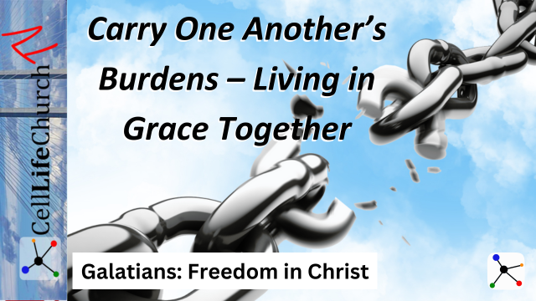

Are you living out the freedom Christ has given you by extending grace to others? True freedom in Christ is not only experienced personally but is also expressed in how we serve and support one another. Join us as we discover how to live in grace and carry each other's burdens in love.

## Introduction

Welcome to the final session of our *Galatians: Freedom in Christ* series. Over the past few weeks, we have explored how to walk in the freedom that Christ has secured for us.

We began by understanding *The True Gospel – No Substitutes*, where we learned the importance of holding fast to the pure gospel. Then, in *Grace Over Law – Faith That Sets Us Free*, we discovered that salvation comes by grace through faith alone. *The Power of Faith* taught us that faith transforms us into God’s children, and in *Walking in Freedom, Not Bondage*, we learned how to stand firm in that freedom. Last time, in *Life in the Spirit – Bearing Good Fruit*, we explored how a Spirit-filled life produces fruit that reflects Christ’s character.

Today, we conclude this series by exploring *Carry One Another’s Burdens – Living in Grace Together*. Paul challenges us to go beyond personal faith and express our freedom by serving others. True freedom is experienced when we extend the same grace to others that Christ extended to us.

## Bearing One Another’s Burdens Reflects Christ’s Love

Paul encourages believers to bear one another’s burdens in Galatians 6:2:

### Galatians 6:2

(2)  Carry each other's burdens, and in this way you will fulfill the law of Christ.

When we bear each other’s burdens, we fulfill the law of Christ, which is rooted in love. Jesus Himself exemplified this by carrying the weight of our sin and offering us grace and forgiveness. He calls us to do the same for others.

Bearing burdens does not mean merely sympathizing with someone’s struggles but actively stepping into their situation to help lift their load. It is easy to say, “I’ll pray for you,” but walking alongside someone in their struggles requires sacrifice, patience, and love.

Consider how Jesus carried the burdens of those He encountered. He healed the sick, comforted the brokenhearted, and met people in their place of need. Likewise, we are called to embody this same compassion in our relationships.

The word "burdens" here refers to oppressive weights that are too heavy for one person to carry. This could be physical, emotional, or spiritual burdens. As followers of Christ, we are called to help alleviate these burdens by offering prayer, encouragement, and tangible support.

Who in your life is carrying a heavy burden right now? Ask God to show you how you can come alongside them this week. It could be offering a listening ear, providing a meal, or simply being present in their time of need.

## Living in Grace Requires Humility and Gentleness

Paul shares in Galatians 6:1 a call to restore others with gentleness:

### Galatians 6:1

(1)  Brothers and sisters, if someone is caught in a sin, you who live by the Spirit should restore that person gently. But watch yourselves, or you also may be tempted.

Restoring others requires a posture of humility and gentleness. Paul warns that when we seek to help others who are struggling with sin, we must do so with grace and care, being mindful not to fall into temptation ourselves.

Restoration is not about condemnation or judgment, it is about pointing others back to Christ. Just as Jesus restored Peter after his denial, we are called to offer grace and help guide others back into right standing with God.

The Greek word for "restore" used here is *katartizo*, which was a medical term for setting a broken bone. It implies a careful, gentle process of healing and alignment. We are not called to break others down with harsh judgment but to lovingly guide them back to spiritual health.

Are there relationships in your life where restoration is needed? Ask the Holy Spirit to give you the humility and gentleness needed to approach that person and extend grace. Be mindful that restoration is a process that takes time and patience.

## Serving Others Demonstrates Freedom in Christ

Paul emphasizes that serving others is an expression of true freedom in Galatians 5:13:

### Galatians 5:13

(13)  You, my brothers and sisters, were called to be free. But do not use your freedom to indulge the flesh; rather, serve one another humbly in love.

Freedom in Christ is not a license to pursue selfish desires but an opportunity to serve others. When we use our freedom to love and serve, we demonstrate that we are truly living in grace. Serving others shifts our focus from self-centeredness to Christ-centeredness. Life is no longer about ourselves, it is now about reflecting Christ to others.

Jesus modeled this servant-hearted life when He washed His disciples' feet, showing that true greatness comes through humility and service. When we serve others, we reflect His character and make His love visible.

Serving others is an act of worship. Romans 12:1 reminds us to present ourselves as living sacrifices, holy and pleasing to God. Our service, motivated by love, becomes a reflection of Christ’s selfless sacrifice on the cross.

Look for opportunities this week to serve someone in a meaningful way. It may be volunteering your time, helping a neighbor, or offering encouragement to a friend. Serving others is a tangible way to express your freedom in Christ and reflect Christ to someone who needs Him.

## Conclusion

Living in grace means bearing one another’s burdens, restoring others with humility, and using our freedom to serve. When we extend the same grace that we have received, we reflect Christ’s love and embody true freedom.

The key takeaways from today’s teaching are:

* Bearing one another’s burdens fulfills the law of Christ and reflects His love.
* Living in grace requires humility and gentleness in restoring others.
* Serving others demonstrates that we are truly living in the freedom Christ has given us.

As we conclude this series, may we continue to walk in the freedom Christ has given us, bearing fruit that glorifies God and loving others as He loves us. Let us go forward, living in grace and reflecting Christ in all we do.