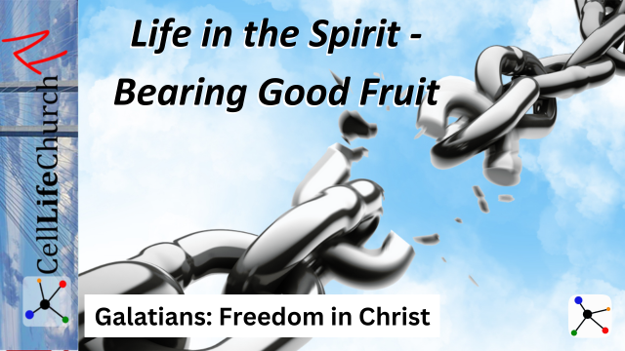Life in the Spirit - Bearing Good Fruit

Are you truly living in the freedom Christ has given you? A life in the Spirit produces visible fruit—love, joy, peace, and more. But how do we cultivate these qualities daily? Join us as we explore what it means to bear good fruit and walk in step with the Spirit.

## Introduction

Welcome back to our series, *Galatians: Freedom in Christ*. Throughout this journey, we've been uncovering how to live fully in the freedom Jesus purchased for us through his sacrifice on a Roman cross.

We began by laying the foundation with *The True Gospel – No Substitutes*, where we saw how holding to the pure gospel keeps us from spiritual deception. Then, we explored *Grace Over Law – Faith That Sets Us Free*, discovering that salvation comes by grace through faith, not by works. In *The Power of Faith*, we learned how faith transforms us into God’s children, and in our last session, *Walking in Freedom, Not Bondage*, we uncovered how to stand firm in our freedom and walk by the Spirit.

Today, we turn to a vital question: What does a life in the Spirit truly look like? Jesus teaches us in Matthew 7:16 that a tree is known by its fruit, and Paul teaches us that when we walk in the Spirit, we bear the fruit of the Spirit. Let’s discover what it means to cultivate this fruit and live in step with the Holy Spirit every day.

## The Fruit of the Spirit is Evidence of a Transformed Life

The evidence of a transformed life is shown through the fruit that we bear. Paul teaches us what the fruit of the Spirit is in Galatians 5:22-23:

### Galatians 5:22-23

(22)  But the fruit of the Spirit is love, joy, peace, forbearance, kindness, goodness, faithfulness,  (23)  gentleness and self-control. Against such things there is no law.

Paul describes nine attributes that flow from a life surrendered to the Holy Spirit. These qualities are not produced by sheer effort; they are the evidence of God at work within us. Just as a healthy tree produces good fruit, a Spirit-filled life reflects God's character.

Consider the analogy of fruit-bearing trees. An apple tree does not struggle to produce apples; it naturally bears fruit when it is rooted in good soil, properly watered, and given sunlight. In the same way, we do not bear the fruit of the Spirit through sheer willpower but through abiding in Christ and allowing His Spirit to work in us.

Take a moment to evaluate what kind of fruit is growing in your life? Is your heart filled with love and peace, or do bitterness and impatience take root? This week, ask God to cultivate the area where you struggle most.

Choose one fruit of the Spirit to intentionally cultivate this week. If it’s kindness, look for ways to serve others. If it’s self-control, ask the Holy Spirit to guide your choices.

## Walking in the Spirit Requires Daily Surrender

Paul explains the difference between walking in the Spirit versus walking in the flesh in Galatians 5:16-17:

### Galatians 5:16-17

(16)  So I say, walk by the Spirit, and you will not gratify the desires of the flesh.  (17)  For the flesh desires what is contrary to the Spirit, and the Spirit what is contrary to the flesh. They are in conflict with each other, so that you are not to do whatever you want.

There is an ongoing battle between our flesh and the Spirit. The desires of our sinful nature pull us in one direction, while the Holy Spirit leads us toward godliness. Walking in the Spirit is not a one-time decision; it is a daily, moment-by-moment surrender.

Surrendering to the Spirit means choosing God’s way over our own. It means taking every thought captive as we learn in 2 Corinthians 10:5, resisting temptation as James teaches in James 4:7, and seeking God’s wisdom in all things as it says in Proverbs 3:5-6.

When we walk in the Spirit, we develop spiritual habits such as prayer, studying God’s Word, and being in fellowship with other believers. These habits keep us aligned with God’s will and strengthen us to resist the pull of the flesh.

What influences your daily decisions, the desires of the flesh or the guidance of the Spirit? Begin each day by praying, “Lord, please lead me today by the Holy Spirit.” Be intentional about inviting Him into your thoughts, words, and actions.

Before making major decisions, pause and ask, “Is this in line with God’s will? Does this reflect the fruit of the Spirit?” Let the Holy Spirit shape your responses.

## Bearing Good Fruit Impacts Others

When we bear good fruit, we positively impact those around us. Jesus explains how we are connected to Him in John 15:5:

### John 15:5

(5)  "I am the vine; you are the branches. If you remain in me and I in you, you will bear much fruit; apart from me you can do nothing.

Jesus makes it abundantly clear that our ability to bear fruit comes from abiding in Him. The more we stay connected to Christ, the more His life flows through us, producing spiritual fruit. And this fruit is not just for us; it blesses those around us.

Our families, workplaces, and communities need the evidence of Christ in us. A kind word, a patient response, an act of selfless love—these small moments reflect Jesus and point others to Him.

The world is watching us. We stand out. The world stands for selfishness, control, and self-reliance. Jesus calls us to something different. We cannot accomplish anything in this world with true meaning unless it is from Jesus and through the power and fruit of the Spirit.

Who in your life needs to experience the love of Christ through you? Your fruit is meant to nourish and bless others. This week, be intentional in showing patience to a difficult person or extending kindness to someone in need.

Think of one way you can use your spiritual fruit to serve someone this week. Send an encouraging note, offer forgiveness, or lend a helping hand. Bearing fruit means making a difference in the lives of others.

## Conclusion

Living in the Spirit means bearing fruit that reflects Christ’s character. It is not about striving in our own strength but about surrendering to the Holy Spirit daily.

The key takeaways from today’s teaching are:

* The fruit of the Spirit is the evidence of a transformed life.
* Walking in the Spirit requires daily surrender and intentionality.
* Bearing good fruit impacts others and reflects Jesus to the world.

Next time, we will wrap up our *Galatians: Freedom in Christ* series with *Carry One Another’s Burdens – Living in Grace Together*, where we will explore how to support, encourage, and uplift each other in love. You won’t want to miss it!