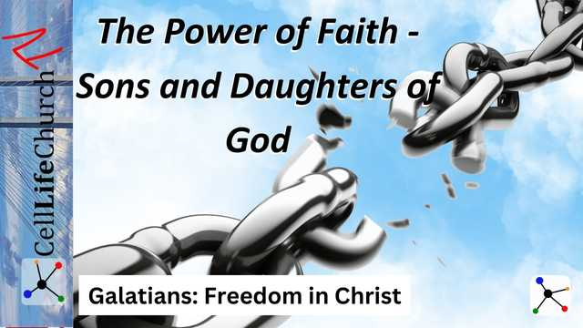
The Power of Faith – Sons and Daughters of God
Many people live as if they are outsiders when it comes to God’s promises, but through faith in Jesus, we are no longer slaves—we are sons and daughters of God! Join us as we explore Galatians 3:23-29 and discover the true power of faith in Christ!

Introduction
Welcome back to our Galatians: Freedom in Christ series! So far, we’ve uncovered life-changing truths from the book of Galatians. In our first teaching, The True Gospel – No Substitutes, we saw how the gospel can be distorted and why we must hold onto the unchanging truth of Jesus Christ. In our second teaching, Grace Over Law – Faith That Sets Us Free, we learned that salvation comes by grace through faith, not by works of the law.
But what happens when we put our faith in Jesus? How does it change our identity?
Many people struggle with feelings of unworthiness, believing they have to prove their faith or earn God’s love. But the Bible tells us a different story. Through faith in Christ, we become sons and daughters of God; heirs to His promises and no longer bound by fear, shame, or the burden of the law.
Today, we are going to explore The Power of Faith and how it transforms us from slaves to beloved children of God.

Faith Transforms Us – From Slaves to Sons
Let’s start by reading Galatians 3:23-26.

Galatians 3:23-26
(23) Before the coming of this faith, we were held in custody under the law, locked up until the faith that was to come would be revealed. (24) So the law was our guardian until Christ came that we might be justified by faith. (25) Now that this faith has come, we are no longer under a guardian. (26) So in Christ Jesus you are all children of God through faith,
Before Jesus, the law acted as a guardian, like a tutor guiding and restraining people until Christ came. But now, through faith, we are no longer bound by the law’s demands. We are children of God, not slaves to religious rules.
Yet many believers still live as if they are under the law, feeling like they have to earn their place in God’s family. Paul reminds us that faith in Christ has already secured our identity.
To apply this to our life we must:
- Stop striving to “prove” yourself to God—your faith in Jesus is enough.
- When doubt creeps in, remind yourself: I am a child of God, not a slave to fear!
- Let go of legalism and embrace the freedom of a loving relationship with your Father.
Take a moment to reflect—are you living as a son or daughter of God, or as a slave to religious performance? Declare today, "I am a child of God through faith in Christ!" Remind yourself of this often.

In Christ, We Are One Family
Paul teaches us that we are one family in Galatians 3:27-28.

Galatians 3:27-28
(27) for all of you who were baptized into Christ have clothed yourselves with Christ. (28) There is neither Jew nor Gentile, neither slave nor free, nor is there male and female, for you are all one in Christ Jesus.
When we put our faith in Jesus, we are clothed in Christ. That is, we are covered in His righteousness. Our earthly labels no longer define us.
In a world full of division—by race, social status, national identity, politics, and background—Paul reminds us that in Christ, we are one family. This means there is no place for pride, discrimination, or exclusion in the body of Christ. Our faith unites us.
To see this in our lives today we must:
- See others through the lens of faith, not worldly status.
- Break down walls of division—embrace unity in Christ.
- Treat every believer as your brother or sister in the family of God.
Who have you distanced yourself from because of differences? This week, take a step toward reconciliation and show Christ’s love to someone. We are one family in Him.

We Are Heirs of God’s Promises
Finally, Paul writes in Galatians 3:29

Galatians 3:29
(29) If you belong to Christ, then you are Abraham's seed, and heirs according to the promise.
As children of God, we are not just accepted; we are heirs of His promises. Everything God promised to Abraham is now ours through faith.
Think about that for a moment. You are not just forgiven—you are blessed, chosen, and destined for an eternal inheritance. The enemy wants you to believe you are unworthy, but the truth is that God has already declared you His heir.
Abraham was promised blessing, provision, protection, and a future. As believers, we step into these same promises. We are royalty in God’s Kingdom.
As heirs in the Kingdom of God we must:
- Stop living with a mindset of lack—you are an heir to God’s promises.
- Walk confidently in the authority God has given you as His child.
- When the enemy whispers lies of unworthiness, remind him, “I am an heir of Christ!”
What promise of God do you need to claim in your life today? Speak it out loud and stand on the promises in His Word. You are a child and heir of the King!

Conclusion
The power of faith changes everything. We are no longer slaves to the law, we are sons and daughters of God.
The key takeaways from today’s teaching are:
- Faith transforms us—we are no longer slaves but children of God.
- In Christ, we are one family—breaking down every worldly division.
- We are heirs of God’s promises—secure in His love and inheritance.
Wake up each day and remind yourself, “I am a child of God, I am free, and I am an heir of His promises!”
Next time, we will explore what it means to walk in freedom and not fall back into bondage. How do we resist legalism and live out our faith with confidence? Stay tuned for our next teaching, Walking in Freedom, Not Bondage.

