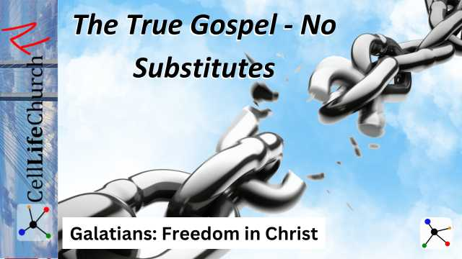
The True Gospel – No Substitutes
Many things in life promise freedom, but only one gospel truly sets us free. Let’s explore how Paul’s message to the Galatians warns us to stay anchored in the freedom in Christ.

Introduction
Welcome to our new teaching series, Galatians: Freedom in Christ. This series will walk us through Paul’s passionate letter to the Galatians, showing us how to live in the grace and freedom Jesus offers.
Paul’s letter wasn’t just written to a group of early Christians—it speaks to us today. We live in a world filled with different messages about what it means to be saved, loved, and accepted by God. Some say you need to work harder, follow religious rules, or achieve a certain status. Others twist the gospel into something it was never meant to be. But Paul makes one thing clear: there is only one true gospel, and we must guard it carefully.
Today, we begin by looking at Galatians 1:6-10, where Paul warns the Galatians—and us—not to be deceived by false versions of the gospel. Instead, we are called to stand firm in the freedom in Christ that only the true gospel brings.

Guard Against False Gospels
We read in Galatians 1:6-7

Galatians 1:6-7
(6) I am astonished that you are so quickly deserting the one who called you to live in the grace of Christ and are turning to a different gospel— (7) which is really no gospel at all. Evidently some people are throwing you into confusion and are trying to pervert the gospel of Christ.
Paul wastes no time addressing his concern for the Galatians. Unlike his other letters, where he usually begins with words of encouragement, here he jumps straight into a warning. The Galatians were in danger of walking away from the gospel of grace and embracing something that could never save them.
The “different gospel” they were turning to was not an entirely new religion. It was a subtle distortion of the truth. False teachers were telling them that faith in Jesus wasn’t enough; they also needed to follow Jewish laws and traditions to truly be accepted by God. Paul boldly declares that anything added to the gospel is no gospel at all.
This warning is just as urgent today. We may not have teachers telling us to follow Jewish law, but there are plenty of voices trying to alter the gospel. Some preach a message of self-sufficiency: “Be a good person, and you’ll be fine.” Others promote a prosperity-based faith: “If you really trust God, He will give you everything you want.” And still others twist grace into a license to sin: “Since God forgives, it doesn’t matter how you live.”
Think of counterfeit money. It looks real, but it has no real value. Banks train their employees to spot counterfeits—not by studying fakes, but by thoroughly knowing the real thing. The better they know the true currency, the easier it is to recognize fraud.
The best way to guard against false gospels is to know the true gospel deeply. Just as bankers study real money, we must study God’s Word. Take time this week to read through Galatians on your own, praying for God to reveal His truth to you. Ask yourself:
- Am I believing any distortions of the gospel?
- Do I think I need to "earn" God’s love?
- Have I been adding anything to Jesus’ finished work?

We Please God, Not People
We read in Galatians 1:10

Galatians 1:10
(10) Am I now trying to win the approval of human beings, or of God? Or am I trying to please people? If I were still trying to please people, I would not be a servant of Christ.
Paul makes a strong statement here. If our main goal is to please people, we are not truly serving Christ. The Galatians were being influenced by false teachers who wanted to blend the gospel with Jewish customs. These teachers were more concerned with popularity than with truth.
Pleasing people can be dangerous in our faith. It often leads to compromise, where we adjust our beliefs or behaviors to fit in. This can happen in big ways, like denying biblical truth to avoid conflict, or in subtle ways, like watering down our convictions so we don’t offend anyone.
Paul’s words remind us that the only approval that truly matters is God’s. Jesus Himself faced rejection because He refused to conform to human expectations. If He was not swayed by public opinion, we should not be either.
Think about social media. Many people post filtered, curated versions of their lives to gain approval. If a post does not get enough likes, they might delete it. The same pressure can affect our faith. We may hesitate to speak about Jesus because we’re afraid of what others might think. We might stay silent when God prompts us to share the truth.
God calls us to stand firm in who He has called us to be, not in what others expect of us. This week, challenge yourself in these ways:
- If you tend to seek approval, pause before making a decision and ask, Am I doing this for God or for others?
- If you struggle with fear of rejection, pray for boldness to live out your faith confidently.
- Consider sharing a scripture or testimony online—not to gain approval, but to glorify God.
The more we focus on pleasing God, the less power people’s opinions will have over us.

The Power of the True Gospel
We read in Galatians 1:8

Galatians 1:8
(8) But even if we or an angel from heaven should preach a gospel other than the one we preached to you, let them be under God's curse!
Paul doesn’t hold back here. He declares that even if an angel from heaven preaches a different gospel, that message should be rejected! Why? Because the true gospel has the power to save and transform lives.
Satan does not always attack through outright lies. He often twists the truth just enough to deceive. Throughout history, false teachings have led many astray, even forming entire religions based on messages that contradict the gospel of Jesus Christ. That is why Paul’s warning is so strong. The true gospel must not be changed, watered down, or replaced.
Only the gospel of Jesus’ death and resurrection, received by faith, brings true freedom. Anything else enslaves us—whether it’s legalism, self-righteousness, or worldliness.
Imagine someone lost in the wilderness. They have a map, but instead of following it, they decide to take a shortcut. The shortcut leads them deeper into danger, not to safety. That is what happens when people follow a distorted version of the gospel. It might seem easier, but it leads them away from Christ.
The true gospel leads to freedom in Christ. This week, reflect on these questions:
- Am I standing firm in the true gospel, or have I let culture, tradition, or personal opinions shape my beliefs?
- Do I fully trust that Jesus alone is enough, or am I trying to “earn” my salvation?
- Am I actively sharing the true gospel with others, or am I staying silent?
Make it a goal to share your faith this week—whether through a conversation, a testimony, or an encouraging word. The world needs the true gospel, and we are called to proclaim it boldly.

Conclusion
Paul’s message to the Galatians is clear: Don’t fall for counterfeits. Stand firm in the gospel of grace.
As we reflect on today’s teaching, let’s remember:
- Guard against false gospels by knowing God’s Word.
- Live for God’s approval, not the world’s.
- Hold fast to the true gospel, because only it brings real freedom.
Ask yourself, “Where have I drifted from the pure gospel?” This week, commit to spending extra time in God’s Word and asking the Holy Spirit to guide you into deeper truth.
Next time, we will explore Grace Over Law – Faith That Sets Us Free and discover how God’s grace, not our works, brings true salvation. You won’t want to miss it!

